U.S. Government: What Kind of National Leadership Do We Need?
Pundits, politicians, and prognosticators are referring to the 2024 election as the most consequential in American history. In the aftermath of the 2020 presidential election where legal challenges and a January 6, 2021, attack on the Capitol reflected the nation’s deep divide, American citizens are bracing for another general election campaign season.

The 2020 presidential campaign in the United States was estimated to cost $14.4 billion. Candidates vie for votes through extensive television advertising, rallies, debates, and social media campaigns among other strategies. In many cases, candidates come to voters with stock addresses and talking points. Today’s deliberative forum focuses on voters’ concerns and what they would like to see in our nation’s president, indeed an influential leader of the free world.

Many deliberative dialogue resources focus on issues – voting, policing, vaccines, and immigration, among many others. Forums engage small groups of people talking about potential actions for addressing a community issue as well as consequences or tradeoffs for those actions. This dialogue resource is different. It calls upon our understanding of America’s guiding principles and values and our opinions about the leadership qualities needed to address both domestic and global challenges. As such, the three perspectives use open-ended questions for participants to discuss.

Perspective #1 American Patriotism and Values: What will it take to value the roots of the republic’s democracy? How should our nation’s core values of freedom and equal opportunity for all be protected?

Perspective #2 Exemplary Leadership: What presidential leadership qualities are needed for the United States in the 21st century? What leadership role should the United States play in the world?

Perspective #3 Accountability Under the Law: How do candidates articulate their understanding of the Constitution’s First Amendment freedoms? Is the separation of powers as the Founders organized them functioning adequately?

GROUND RULES FOR A FORUM
- Give equal time (15-20 minutes) to each Perspective.
- Consider all the perspectives fairly.
- Listening is just as important as speaking.
- No one or two individuals should dominate.
- Maintain an open a respectful atmosphere.
- Everyone is encouraged to participate.

Perspective #1 American Patriotism and Values
The nation will celebrate its 250th birthday in 2026. Speakers and presentations will quote the Declaration of Independence, “We hold these truths to be self-evident, that all men are created equal, that they are endowed by their Creator with certain unalienable Rights, that among these are Life, Liberty and the Pursuit of Happiness.”

The Library of Congress exhibit, Creating the United States, describes the nation’s set of beliefs: “Among them was the idea that all people are created equal, whether European, Native American, or African American, and that these people have fundamental rights, such as liberty, free speech, freedom of religion, due process of law, and freedom of assembly. America's revolutionaries openly discussed these concepts.” "Freedom and the power to choose should not be the privilege of wealth. They are the birthright of every American." President George H. W. Bush.

The definition of “all people” mentioned above will include people from all nationalities. In the 21st Century, the nation will be more diverse than at any other time in our history. More than 50% of Americans will count Spanish as their first language. As voters think about candidates, listen to debates, and read campaign platforms, is it possible to discern how a candidate speaks about the nation’s core values and ideals?

Considerations
What should citizens expect of the president and federal government?
What harms threaten the American way of life?
What American ideals do you want to be protected?
Do you have other thoughts or concerns?

Perspective #2 Exemplary Leadership
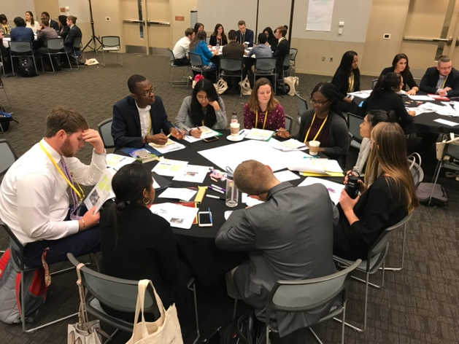
As American culture transitions from the Baby Boom Generation to Millennials and Gen X, new leaders with personal histories influenced by 9/11, climate change, the Covid pandemic, and international wars will assume elected positions. Will the events of the 21st Century influence leaders differently from 20th-century challenges? The presidency, as Franklin D. Roosevelt put it, “is preeminently a place of moral leadership.” President Ronald Reagan said, “The greatest leader is not necessarily the one who does the greatest things. He is the one who gets the people to do the greatest things.”

Former Member of the House of Representatives, Jill Long Thompson writes, “In a democracy, we do not each get our way, but we must respect the right we all have to work with our fellow citizens and address our challenges in a way that moves us forward as a people.” (The Character of American Democracy. Value-based Leadership)

Thompson asserts that value-based leadership is critical for preserving democracy. She argues that leaders need to speak truthfully, uphold justice for all citizens, and use self-control or temperance in listening to people with different opinions.

In the current political environment, in the United States and globally, the question of executive branch authority is a subject of discussion. In some cases, partisan gridlock, and the failure to reach consensus calls for strong leadership. Potential consequences, however, could result in weakening the legislative and judicial branches of government and silencing dissent and/or retaliation for those who disagree.

In terms of global leadership, the United States has been regarded as an influential global leader. Has the nation’s leadership been strengthened or weakened? What role should the United States play?

Considerations
What presidential leadership qualities do you value and from which U.S. presidents?
Are there leadership styles that cause concern?
What are the most important challenges facing the United States?
Are there other things to consider when voting for presidential candidates?

Perspective #3 Accountability Under the Law
The US Constitution serves as our guiding framework and is greater than any one leader. It transcends political parties and time. The Constitution promotes essential freedoms as presented in the First Amendment and provides for due process of the law where all people are treated fairly.

Article 14 asserts that as citizens of the United States and the state in which they reside, all shall not be deprived of the pursuit of life, liberty, and the pursuit of happiness. Just as people are expected to abide by the law, so shall government protect the rights of its people.

Tensions are always at play when considering Constitutional matters. The tension between federal and state authorities relative to the Covid pandemic is one example. The Supreme Court often rules on individual freedom versus the common good. The separation of powers among the executive, legislative, and judicial branches often result in tension among the branches.

Considerations
What concerns do you have about tensions in the government?
How do you want candidates to address equality of opportunity?
What forces or headwinds are threats to basic Constitutional freedoms?
What other concerns do you have?

Reflection

Please take some time to reflect on your time together.

- Were there areas of significant agreement from one or more perspectives?

- What portions of your discussion sparked the most interest?

- Please identify healthy tensions when disagreements occurred.

Thank you for the privilege of your time.

Post-Forum Questionnaire

This link will take you to a two-question questionnaire.

Citation for Rep. Jill Long Thompson's quote. Permission granted by Brookings Institution.
Kamarck, E., Allen, J. R., Michael Hais, D. R., & Norman Eisen, E. D. P. (2019, September 24). The character of American democracy: Values-based leadership. Brookings Institution

© 2023, Southern Deliberative Democracy Network in partnership with the National Issues Forums Institute.

U.S. Government: What Kind of National Leadership Do We Need?
Lead Writer: R. Gregg Kaufman
Editors: Erin Payseur Oeth, Mark Wilson, and Herman Lehman

