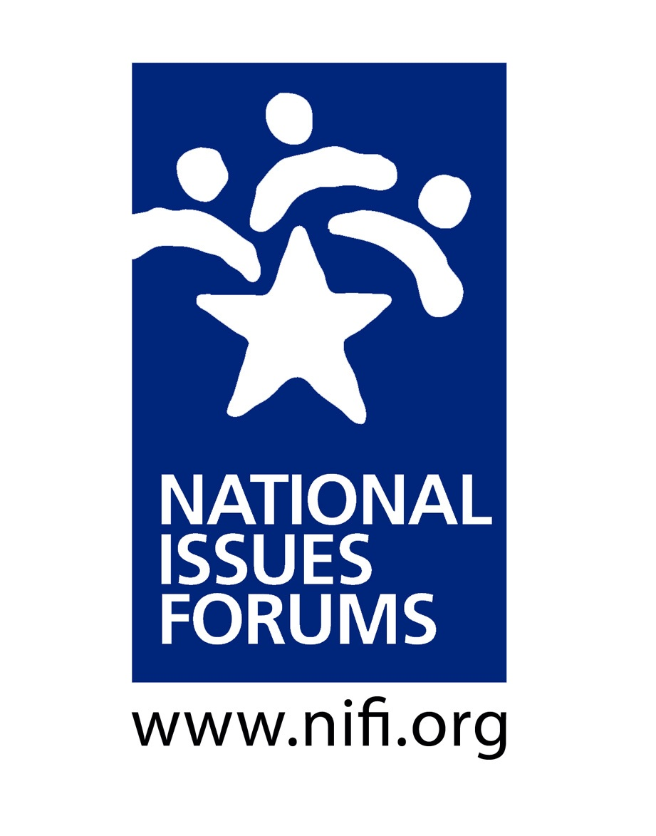

INTRODUCTION & GROUND RULES ___ minutes
Purpose: Look at Alternative Approaches to the Issue and Hear Different Points of View
- This is not a debate; we’re not here to “win” an argument.
- We’ll look carefully at alternative approaches—all of them with trade-offs and drawbacks.
- At the close of the forum, we’ll reflect on what we’ve heard, looking for common ground, but also recognizing remaining areas of tension or ambivalence.
- We’ll try to think about what we might be willing to postpone or give up to make progress now.

The Moderator’s Role: Serving as an Impartial Facilitator
- Helping us have a conversation that is as deliberative as possible.
- Encouraging everyone to consider different viewpoints.
- Watching the time to ensure we talk about all the options and have time for reflections at the end.
- From time to time, pointing to specific questions and ideas in the guide, especially if they represent voices not in the room or trade-offs we haven’t talked about.
- This is your conversation. Please talk to and listen to each other.

Structure: The Four Parts of a Deliberative Forum
- Ground Rules
- Personal Stake
- Deliberating on the Options: Option 1, Option 2, Option 3
- Closing Reflections

GROUND RULES ___ minutes

Some sample ground rules used by forum moderators
- Listen to each other. Listening is as important as speaking.
- Consider each approach with an open mind, looking at its benefits and its trade-offs.
- Everyone is encouraged to participate. No one or two individuals should dominate.
- It’s okay to disagree, but do so with curiosity, not hostility. Learning more about how others think is one of the most interesting parts of a forum.
- Avoid coming to conclusions until we’ve deliberated on all the options.
- Are there additional ground rules we would like add?
- Do we all agree to follow these ground rules and hold one another accountable to them?

PERSONAL STAKE ___ minutes
Some questions moderators often use to encourage participants to talk about their personal stake in the issue

- Why did you decide to participate in the forum today?
- How has this issue affected you personally?
- When you think about this issue, what worries you most?
- How does this problem affect your goals and vision for our country and your community?

OPTION 1: Recap and Questions for Deliberation ___ minutes

This option says children’s health should be the top priority and that our current situation is still too dangerous to resume full-time, in-person learning for everyone. Though research suggests most young children are affected mildly by COVID, those with underlying conditions are more vulnerable. Teachers and staff are at risk, and children could bring the virus home to family members. This option says it is better to be safe than sorry, especially with more contagious variants of the virus emerging.
BUT: Remote learning harms children educationally and emotionally, particularly those with learning disabilities, English-language learners, or those struggling in school. Some may go hungry or be left without adult supervision and support. The damage caused by keeping schools closed far outweighs the risks of opening them.

- Concerns about in-person learning often focus on teachers and staff who are more at risk of severe COVID. But adults in healthcare, grocery and retail stores, police forces and fire departments have worked throughout the pandemic. Are considerations for school staff different? How so?

- Some recommend keeping schools closed until all staff are vaccinated and moving to student vaccinations when available. What should happen if some teachers, staff, and families do not want to be vaccinated?

Option 2: Recap and Questions for Deliberation ___ minutes

This option says full-time, in-person learning is irreplaceable for children so we should do what it takes to fully open schools. Remote learning has enormous drawbacks, as does hybrid learning where teachers instruct children in classrooms and online at the same time. Many experts say schools can openly safely with universal masking and distancing. Nothing is risk-free, but the benefit of opening schools far outweighs the risks.
BUT: Many school districts lack the funds and administrative wherewithal to strictly enforce masking, reduce class sizes, hire additional staff, improve ventilation, and add other safeguards. Many teachers and students will be in unsafe situations which puts us all at risk.

- Is it realistic to believe that all children and adolescents will wear masks consistently and follow other recommendations? What should happen if students (or their parents) are routinely non-compliant?
- To open schools safely, experts recommend routine testing and immediate action if a case is discovered. Should teachers, staff, and students be required to submit to regular testing. Should schools close temporarily if cases are discovered?

Option 3: Recap and Questions for Deliberation ___ minutes

Closing schools hurts some children more than others. Young children miss out on the years when they learn to read. Special education students and English-language learners can lose hard-won skills. Children in communities of color and low-income households often lack internet access, and parents often do not have jobs that allow them to work from home. This option says we should re-open in-person learning first for students most in need, even if others must wait.
BUT: The pandemic has affected all students educationally and emotionally and opening schools only for some would be unfair and divide communities and undermine support for public education.

- Many experts say all schools can re-open safely if they take steps to protect staff and students. Isn’t this where districts should put their attention—not in sorting out which students will attend in person versus those who will learn remotely? Won’t dividing students into groups like this just create division and controversy?
- Don’t teenagers suffer from remote learning just as much? Many feel isolated. Teachers say many skip remote classes or don’t pay attention during them. Shouldn’t we get adolescents back into in-person learning as quickly as possible?

CLOSING REFLECTIONS ___ minutes

The COVID pandemic has unraveled our lives in many ways, and we face difficult decisions on how to get back to normal and when it’s safe to do so. That’s why it’s so crucial to talk about the choices and proposals described in this guide, along with others you might have identified in your deliberations. And it’s essential to think about the advantages and risks of different approaches and how the proposals will work out in real life—in your community’s schools.

Families often struggle deciding on the best approach for their own children. But school systems face an even tougher challenge. They have to work out policies for all the schools and students in situations where teachers, parents, and students often have different priorities and concerns.
- Letting teachers and parents decide when they want to return to full-time, in-person learning sounds like a good solution, but is it realistic? Can schools in your district really provide good remote and in-person options for everyone given limited money and staff? What would they have to do to make such a plan work? What could go wrong that they would need to address?
- How can local schools ensure their decisions are sound and will be accepted by people in the district? Who should they consult? What should they do if there are sharp divisions? What can they do to give everyone more confidence in whatever they decide?
- No matter what decisions are made, educational experts predict that many students will have lost ground during the pandemic—both needed skills and in social and emotional learning. Some have lost loved ones, while others may have gone through economic hard times.
  - What can and should schools do to address these kinds of problems that will last into the coming years?
  - What can community groups and individuals do to address them?

SOME KEY OVERALL QUESTIONS TO CONSIDER:
- Now that we have deliberated, are there ideas or viewpoints you hadn’t considered before?
- Can you now identify any shared concerns or hopes we have discovered in our conversation?
- Can you identify any tensions or disagreements that came up during the forum?
- How has what you heard affected your thinking?
- What questions remain?
- What could you do as an individual?
- What could the community do?
- About what do we want officials in the local district and at the state and national levels to do in our name?

