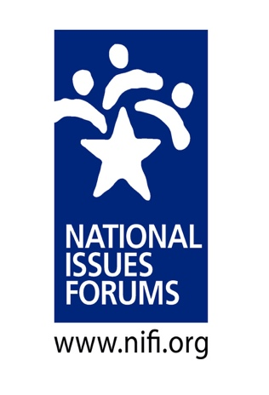

RECOMMENDATIONS FOR DEVELOPING AN OLLI DELIBERATIVE DEMOCRACY COURSE

- Determine the length of the course. A minimum of 90 minutes and preferably two hours is required for a good forum experience.

- Create a course description. Example from University of North Florida OLLI course:
Deliberative Democracy: Civil Discourse About Critical Public Issues

“To deliberate is to carefully weigh civic actions, laws, or policies against the various things that people hold valuable in order to settle on a direction to follow or purpose to pursue. Deliberative Dialogue enables ordinary citizens to engage in political conversation in a civil manner. Unlike watching adversarial debates or listening to expert panelists describe complex policies, deliberative forums draw on the wisdom of citizens as they share and listen to one another’s opinions and seek some degree of common ground.
Participants will deliberate issues including What Should We Do About the Opioid Epidemic? Coming to America: Who Should We Welcome? and What Should We Do? Economic Vitality: How Can We Improve Our Communities? Participants will choose two additional issues.

- Instruction. Deliberative dialogue provides an opportunity for OLLI participants to be actively involved in deliberating critical issues. The primary role of the instructor is to moderate the forums. Please review the moderator resources. In many cases, OLLI members prefer to dialogue rather than be presented with the history or mechanics of the deliberative process. Two hours provides for Q&A and discussion about the strengths and weaknesses of the process. Consider discussing how deliberative dialogue compares and contrasts with other forums of public discourse.

- Issue Guides. The issue guides can be purchased very economically from the NIFI website. https://www.nifi.org/en/nifi-materials

- Schedule

  - Introduction and personal Stake 15 minutes
  - Options or Approaches 3 X 20 min 60 minutes
  - Reflection and Conclusion 15 minutes
  - Q&A What did we do well? 30 minutes
How can we improve?

Frequently Asked Questions

- How are the issue books developed?
The Kettering Foundation and the National Issues Forums Institute work collaboratively with writers and researchers to respond to what people around the country suggest as important issues. Current events also help determine the issues that are named and framed. Drafts of issue guides are tested by focus groups in centers for public life, universities, and NIFI network members and edited into final form before being designed and printed.

- Why do the issue guides provide three options or approaches to considering an issue?
First, deliberation avoids binary or pro v. con discussion. Each of the options is distinctively different and offers both actions and trade-offs. Ideally, people will see particular actions from one or several options as helpful for thinking about the issue in their local context.

- Why is an issue book necessary?
Think about how you would work with professionals to design and build a home. Blueprints and renderings are necessary for first thinking about the project. Once decisions have been made, the final blueprint guides the building process. Changes can be made. Issue books are like blueprints. They are a starting place. Participants can accept and reject portions of the guide and come up with additional ideas. However, three options or approaches with at least 20 minutes for discussion plus the concluding reflections – Did we discover any areas of agreement? – make for a substantive forum.

- What will we get out of the process and what happens next?
Many people come to understand deliberative dialogue as a “new way of talking.” People often find that the ground rules and the neutral moderator are keys to providing the climate for a respectful, civil discussion. Consequently, deliberation fosters positive democratic attitudes and the skills of careful listening, articulating one’s thought clearly, and a collective concern for common ground.

- What does NIFI do with the post-forum questionnaires?
Every year, one of the most recently published issue guides serves as a subject for a national dialogue. The questionnaires are reviewed, tabulated, and often used to write final reports that are sent to legislators at the local, state and federal levels.

- What are the best places to use deliberative dialogue?
Almost anywhere! K-12 education, community civic and nonprofit organizations, faith communities, neighborhood associations, universities, community forums, among many others. The possibilities are limitless. Your OLLI program is a good place to start!

