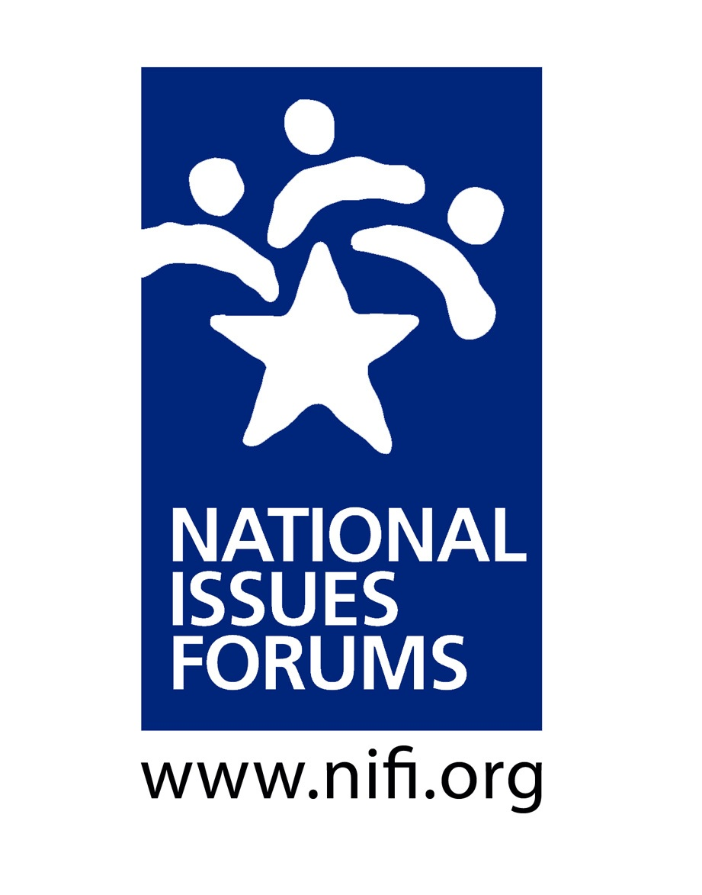

Introduction & Ground Rules ___ minutes
Purpose: Look at Alternative Approaches to the Issue and Hear Different Points of View
- This is not a debate; we’re not here to “win” an argument. We’re here to listen and learn.
- We’ll look carefully at alternative approaches—all of them with trade-offs and drawbacks.
- At the close of the forum, we’ll reflect on what we’ve heard—looking for common ground, but also recognizing remaining areas of tension. We’ll identify areas where we ourselves might be willing to reconsider our initial ideas.
- We’ll try to think about what matters most to us and what we are willing to risk or give up to make progress on resolving this issue.

My Role: Serve as Impartial Facilitator
- I’m here to help us have a conversation that is as deliberative as possible.
- I’ll encourage everyone to consider different viewpoints.
- I’ll watch the time to ensure we talk about all the options and have time for reflections at the end.
- From time to time, I may point to specific questions and ideas in the guide, especially if they represent voices not in the room or trade-offs we haven’t talked about.
- This is your conversation. Please talk to and listen to each other.

Structure: The Four Parts of a Deliberative Forum
- Ground Rules
- Personal Stake
- Deliberating on the Options: Option 1, Option 2, Option 3
- Closing Reflections

Ground Rules ___ minutes

Some sample ground rules used by forum moderators
- Listen to other voices. Listening is as important as speaking.
- Consider each approach fairly, looking at its benefits and its trade-offs.
- Everyone is encouraged to participate. No one or two individuals should dominate.
- It’s okay to disagree, but do so with curiosity, not hostility. Learning more about how others think is one of the most interesting parts of a forum.
- Keep an open mind. Avoid coming to conclusions until we’ve deliberated on all the options.
- Are there additional ground rules we would like add?
- Do we all agree to follow these ground rules and hold one another accountable to them?

Personal Stake: ___ minutes
Some questions moderators often use to encourage participants to talk about their personal stake in the issue
- Why did you come out to the forum today?
- When you think about America’s situation in the world today, what concerns you most? What give you hope?
- How could this country’s relations with the rest of the world affect your own future?

Option 1: Recap and Questions for Deliberation ___ minutes
According to this option, the United States has focused too much on policing and protecting the world and not enough on shoring up its own prosperity and taking care of our own people. It is time to put our own country’s needs first. The United States spends billions on defense and foreign aid while at home, bridges and highways are crumbling, the national debt is rising, and people go bankrupt trying to pay their medical bills. It’s time to stop trying to be the world’s policeman and superpower and invest in our own people.

- If we turn our backs on the world’s chaos, won’t we eventually see the results here—more terrorism, a less stable world economy, more refugee crises, increased risk from diseases that develop abroad?

- Are we willing to step aside and risk giving Russia and China much more influence worldwide?

- Can we maintain preparedness if we cut military spending? Won’t this make us more vulnerable?

Option 2: Recap and Questions for Deliberation ___ minutes
This option says the best way to ensure America’s safety in a dangerous world is to invest in being the world’s strongest power. The greatest threats to the United States—rogue states and terrorists, Russia’s resurging military muscle, China’s growing power—come from outside our borders. Since World War II, overpowering US military might has protected both the world order and our own security, freedom, and prosperity. Investing in military might and working to maintain world order is the very best way to keep our country and people safe and thriving.

- Can we really handle the costs of tackling crises around the world when the U.S. already has mounting debt and a crumbling infrastructure? Doesn’t the massive drain on our tax dollars threaten our future as well?

- Is taking bold military action to address problems abroad always helpful? Do we really understand the complex nature of these foreign crises? Does short term intervention really solve the problem?

Option 3: Recap and Questions for Deliberation ___ minutes
This option argues that the most effective way to respond to today’s international dangers is by building alliances, emphasizing diplomacy, and reducing the risk of future crises by promoting democracy and human rights. Threats like international terrorism and record numbers of refugees fleeing war and devastation simply can’t be solved by the U.S. acting alone. Nor can they be solved by ignoring them. The U.S. will be better off, according to this option, if we work with other nations to identify, respond to, and head off the myriad threats arising in our increasingly interconnected world.

- Shouldn’t we be prepared to act on our own if and when we face threats? Building coalitions to tackle problems sounds good, but it takes time, and other nations don’t always see issues and dangers the same way we do. Can we really depend on them? Do we want to be in a position where we have to depend on other nations?

- Entering into arms reductions agreements with hostile countries like Iran and Russia could leave us vulnerable if they cheat. The same goes for international trade agreements. How can we be sure that other countries will obey the rules if we don’t have the stature and power to enforce them?

Closing Reflections ___ minutes

The world is changing, and the United States itself is a different country than it was after World War II. As we face the future, what is the best way to ensure that America is safe and that our economy and way of life are protected?

It is important to think carefully about the implications of the three approaches presented here. It is EQUALLY IMPORTANT to think about the risks and drawbacks posed by all of them.

- Now that we have deliberated, what do we see as the greatest threat facing America in the future? Do we have a different sense of what it takes to keep America safe than we did before?

- Are there any approaches or policies that we are reconsidering now that we have deliberated? Are we having second thoughts about any ideas we initially thought we supported?

- Have you heard any perspectives today that you hadn’t considered before?

- Can you now identify any shared concerns among the group? What are the issues that still divide us?

- Are there other people or groups you would like to hear from, now that you’ve begun to weigh some of the options before us? Is there any information that you need?

- What do we want our elected officials in Washington to do? Are our expectations reasonable?

