Every American is affected by the divisions and outrage that prevent us from making progress on urgent problems. This issue guide is designed to help people deliberate together about how we should approach the issue.

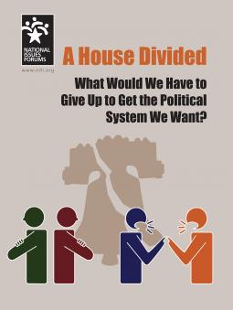
Option 1: Reduce dangerous, toxic talk.
The problem is that the way we talk is poisoning public life. The “outrage industry” rewards people for saying and doing the most extreme things.
Option 2: Make fairer rules for politics and follow them.
The problem is that wealthy, powerful special interests game the political system, making it impossible to find compromise.
Option 3: Take control and make decisions closer to home.
The problem is that our most important decisions are being made too far away from home.

These are difficult questions, and there are no easy answers:
Should we require more accurate, respectful discussion in the media and online, or would that stifle free speech?
Should we reform politics and government to encourage compromise, or will that mean giving up on the changes we really need and want?
Should local communities set policies in areas like health care and the environment, or would that risk the progress we’ve made and make further progress nearly impossible?
Should we crack down on money in politics, or will people just find new ways to evade the rules?
What should we do to get the political system we want? What should we do to revive our ability to work together on the most urgent problems? What are we willing to give up in order to do so?
This issue guide presents three options for deliberation about difficult problems for which there are no perfect solutions. Each option offers advantages as well as risks. And each reflects different ways of understanding what is at stake, forcing us to think about what matters most to us.
The research involved in developing this guide included interviews and conversations with Americans from all walks of life, as well as surveys of nonpartisan public opinion research, subject-matter scans, and reviews of initial drafts by people with direct experience with the subject.
Join this Deliberative Dialogue April 15, 2019!
12:30 pm – 2:30 pm
Image and text from www.nifi.org, retrieved 18 March 2019. (National Issues Forums Institute)

