WHAT YOU SEE | WHAT PLAYERS SEE | MODERATOR TEXT FOR PASTING
LOBBY  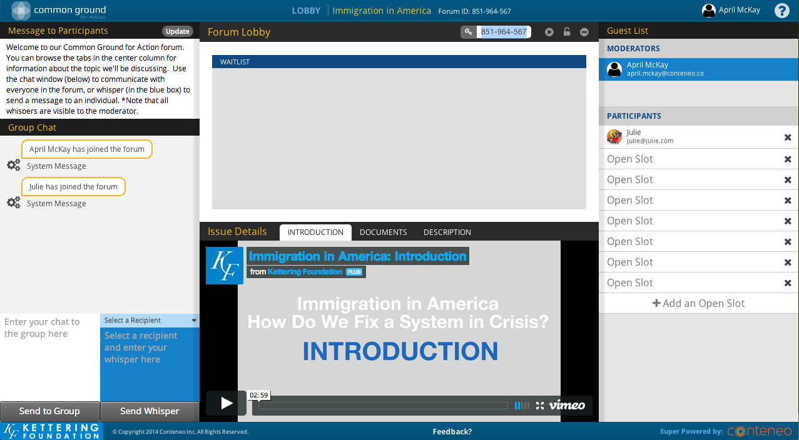 | 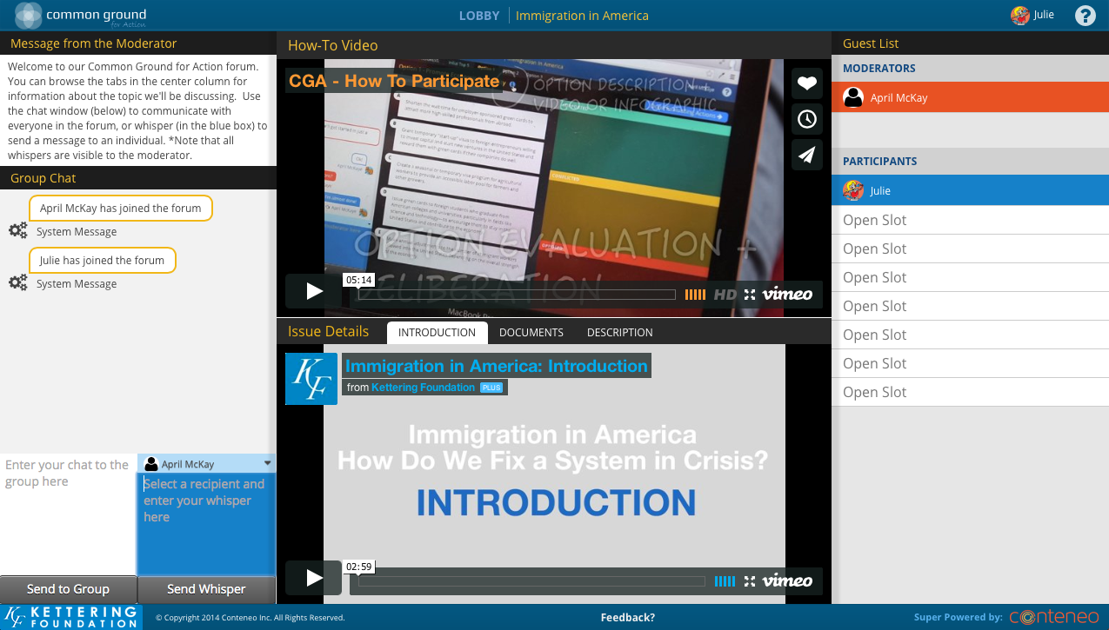 | WHILE WAITING FOR JOINERS  Hi all! I’m your moderator. We’ll be getting started soon.  In the meantime, you can watch the How To Play Video up top, as well as the intro video for the issue we’re going to be talking about today.  Here’s a basic roadmap for our forum today:  • we’re going to pick our initial top 5,  • write our personal stories,  • examine 3 different options,  • and then see where we have common ground and reflect.  GET PEOPLE READY TO GET STARTED  You can download the issue in brief right underneath the DOCUMENTS tab at right— go ahead and do that before we get started.  One more thing, if at any time your computer messes up or you hit the Back button accidentally, all you need to do is go to your History menu and click the “findcommonground.org/game/play+stringofnumbersandletters, and it will bring you RIGHT BACK into the forum where you left off.  You can also download the issue in brief right underneath the DOCUMENTS tab at right— go ahead and do that before we get started.  GO OVER GROUND RULES  Before we start the forum, let me just go over the ground rules:  The purpose of deliberation is to work toward a decision.  Listen and respect other voices. Listening is as important as speaking.  Everyone is encouraged to participate.  No one or two individuals will dominate.  We'll consider each approach fairly.  We'll weigh the benefits and drawbacks of possible actions.  If it starts to feel like the conversation is too fast for us to all to really read and respond to everyone’s comments, anyone can just type PAUSE in all caps at any time and we’ll all quit typing for a second and review all the comments that have come in.  I may do this myself if I feel like we’re moving too quickly!  PERSONAL STAKE  Before we get going, I’d like us all to say how this issue affects us or our family or community.  LET PEOPLE KNOW WHAT’S NEXT  Ok, I’m about to move us into the next part of the forum, the Baseline Top 5. Just choose the top 5 actions that appeal most to you personally; this is just to know your baseline preference.  It’s a lot to read, but let’s try to all be finished in 5 minutes.
WHAT MODERATORS SEE | WHAT PLAYERS SEE | MODERATOR TEXT FOR PASTING
BASELINE TOP 5  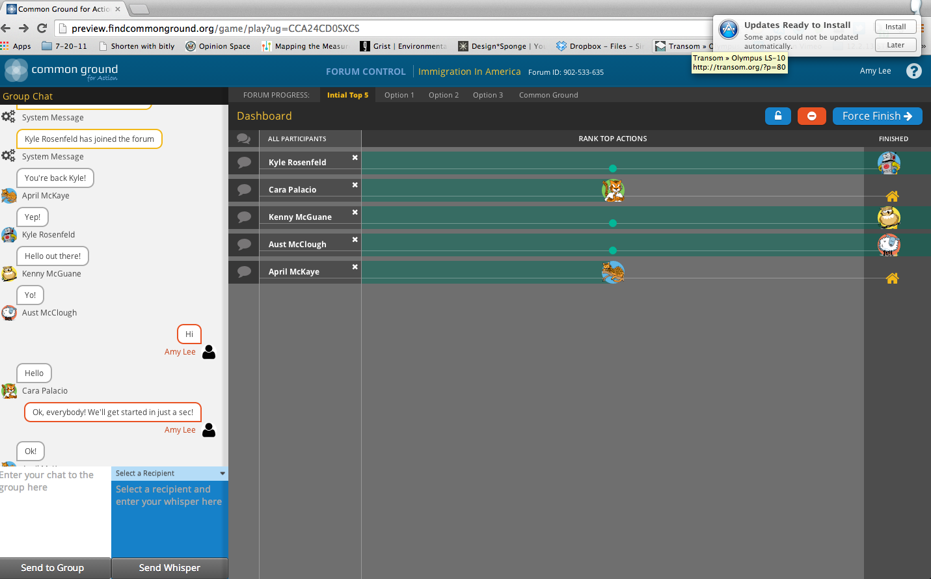 | 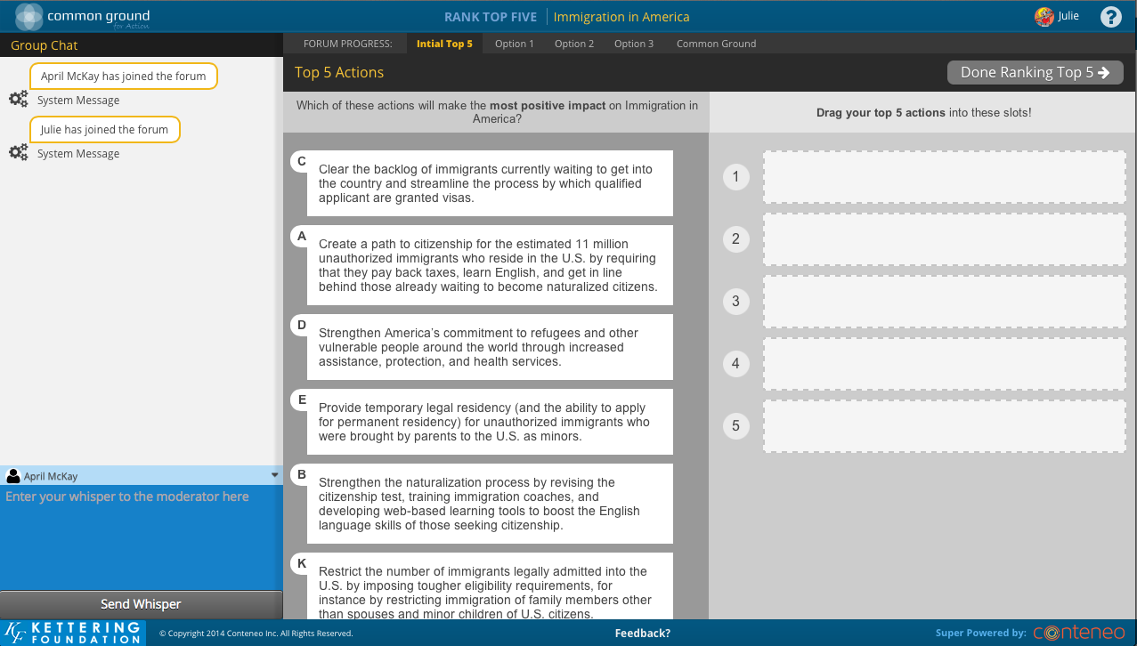 | [REMEMBER, AS OF SPRING 2016, YOU CAN ONLY WHISPER TO INDIVIDUALS WHILE THEY ARE COMPLETING THE BASELINE TOP 5. YOU CAN CHAT TO THE ENTIRE GROUP, BUT IT WILL ONLY SHOW UP IN PARTICIPANTS CHAT BAR ONCE THEY ARE FINISHED WITH THE BASELINE TOP 5 (AND THUS IN THE FORUM HOME/PERSONAL STORY AREA).  SO THIS TEXT IS REALLY ONLY FOR WHISPERING TO INDIVIDUALS IF NECESSARY.  Just click and drag the actions to the right. The top slot is the action you like the very best, the second is your second favorite, and so on.  LET PEOPLE KNOW WHAT’S NEXT  When you finish, take the time out to fill in your personal story, and read those of others!
PERSONAL STORIES (FORUM HOME)  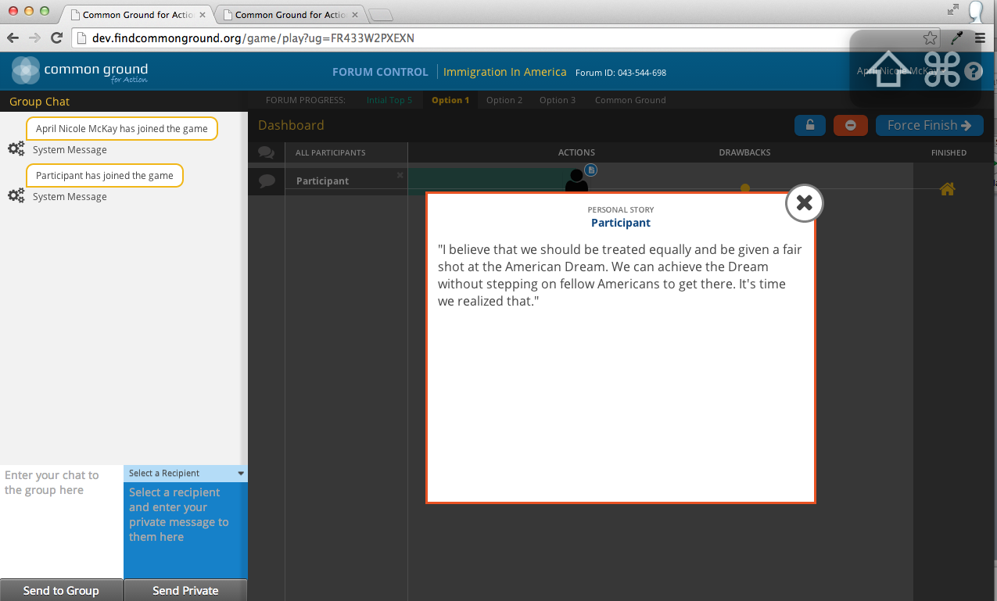 | PERSONAL STORIES (FORUM HOME)  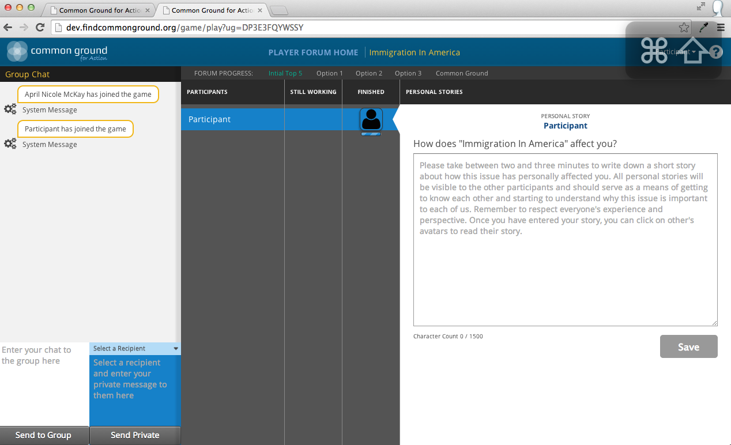 | YOU’LL KNOW PEOPLE HAVE HIT SAVE ON THEIR PERSONAL STORIES WHEN A LITTLE PAGE ICON SHOWS UP NEXT TO THEIR AVATAR.  REMEMBER, PEOPLE SHOW AS FINISHED WHEN THEY’RE DONE WITH THEIR BASELINE TOP 5- YOU STILL NEED TO GIVE THEM TIME TO WORK ON THEIR PERSONAL STORIES BEFORE HITTING “NEXT”/MOVING THE GROUP INTO OPTION 1.  WHEN EVERYONE’S HAD AT LEAST A MINUTE TO WORK ON THEIR PERSONAL STORY,  LET PEOPLE KNOW WHAT’S NEXT  I’m going to move us on in just a minute: PLEASE HIT SAVE NOW, even if you’re not finished with your personal story. You’ll be able to edit it later, but otherwise you’ll lose your work.  We’ll move on as soon as everyone hits SAVE on their personal stories.  Next we’ll do our individual evaluations of the actions and tradeoffs in Option 1: [copy and paste name of Option 1 from issue guide).  Click the little “I” button at the top of the next screen to read the description of the option as a whole, then you will evaluate first the actions in this option, and then the tradeoffs that come with those actions.
WHAT YOU SEE | WHAT PLAYERS SEE | MODERATOR TEXT FOR PASTING
OPTION 1 EVALUATION  (both actions and tradeoffs = 1 screen)  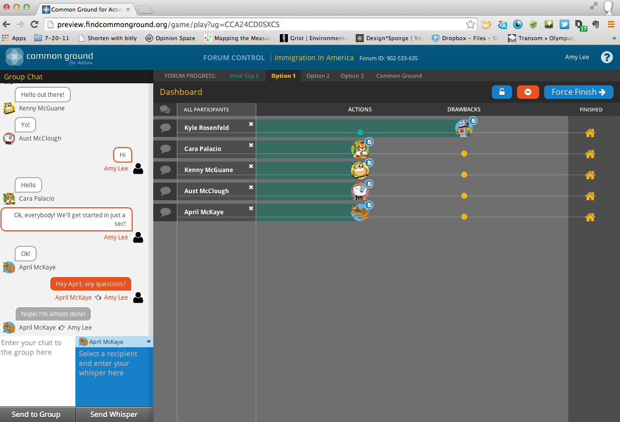 | 1st Screen = Evaluating Actions  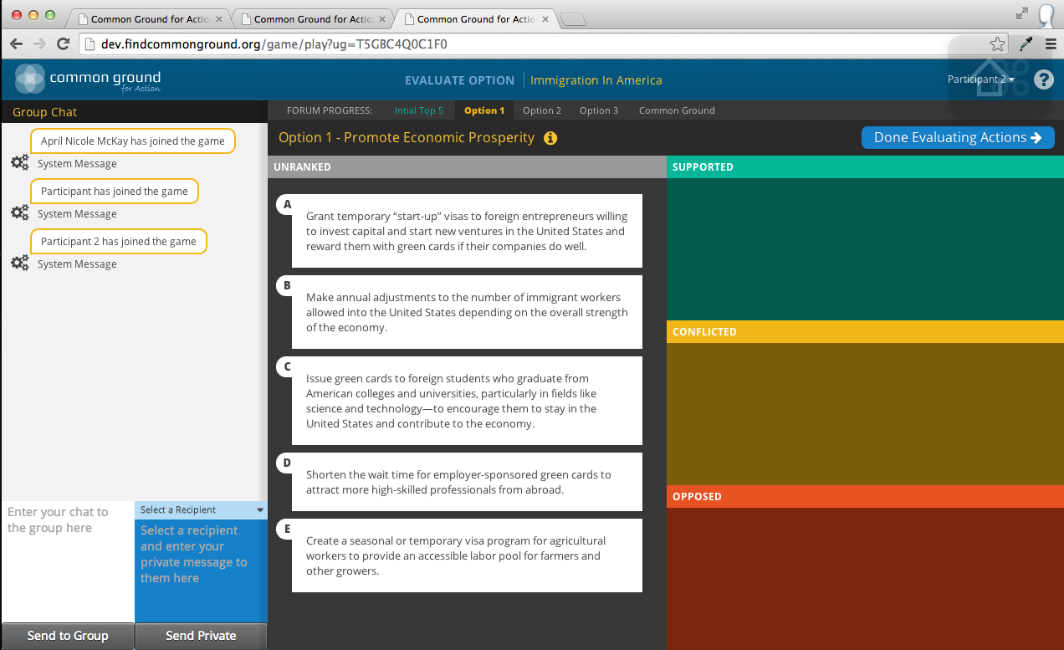 | [REMEMBER, AS OF SPRING 2016, YOU CAN ONLY WHISPER TO INDIVIDUALS WHILE THEY ARE COMPLETING THEIR EVALUATIONS. YOU CAN CHAT TO THE ENTIRE GROUP, BUT IT WILL ONLY SHOW UP IN PARTICIPANTS CHAT BAR ONCE THEY ARE FINISHED.  THIS TEXT IS FOR WHISPERING TO INDIVIDUAL PARTICIPANTS WHO SEEM TO BE STUCK OR HAVE QUESTIONS ABOUT THE “EVALUTING ACTIONS” PROCESS.  Click the little “I” button at the top to read the description of the option as a whole, and a quick video about it.  Take a look at an action, and if you support it, drag it into the Support area. The same for the other categories.  When you’ve evaluated all the actions, click the “NEXT” button at the top right to move on.
 | 2nd screen = Evaluating Drawbacks  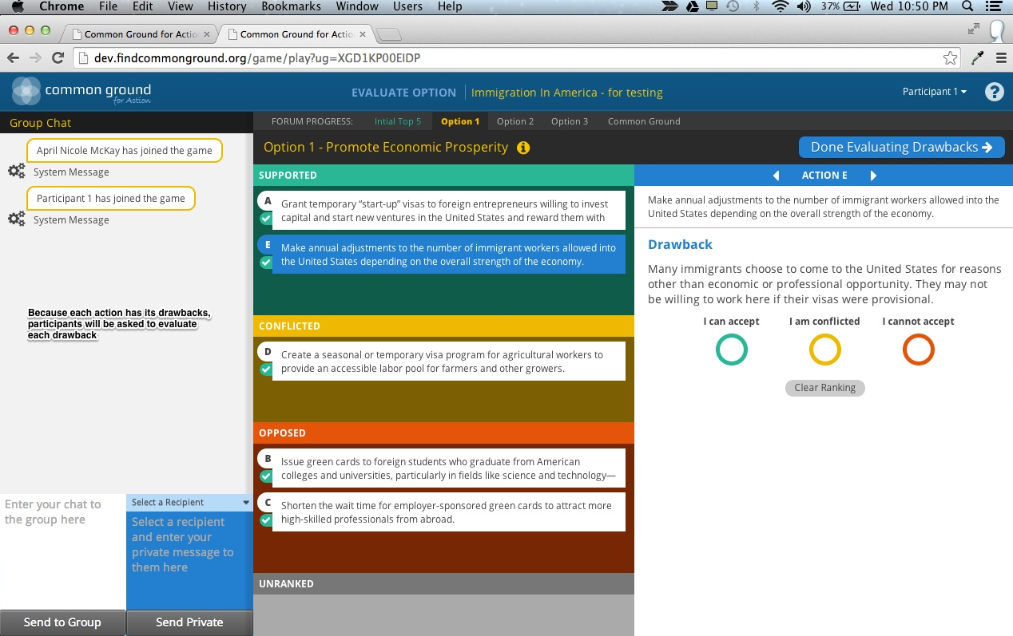 | THIS TEXT IS FOR WHISPERING TO INDIVIDUAL PARTICIPANTS WHO SEEM TO BE STUCK OR HAVE QUESTIONS ABOUT THE “EVALUTING ACTIONS” PROCESS.  Just click the button for whichever you feel about the drawback AS WRITTEN: Can Live With This, Can’t Live With This, or Conflicted.  The drawback you’re evaluating is on the right, the action the drawback is tied to is on the left. You can click different actions on the left and their tradeoffs will show at the right.  If you don’t agree with any of the drawbacks, or don’t think they’re valid, respond to the drawback as written, but make sure to bring up your issue when we start chatting!  When you’re done, click the “NEXT” button at the top right.  THIS TEXT IS FOR THOSE WHO FINISH EVALUATING BEFORE OTHERS—YOU CAN PASTE INTO THE GROUP CHAT AND IT WILL COME THROUGH/EVERYONE WILL SEE IT AS THEY FINISH THEIR INDIVIDUAL EVALUATIONS.  We’ll be ready to start discussing Option 1 soon. In the meantime, you can read personal stories of others and see why they care about the issue of _.  We’ve got a couple people finished, a couple people still working. We’ll move on in just a couple minutes!  THIS TEXT IS FOR PEOPLE WHO HAVEN’T FINISHED IF/WHEN YOU NEED TO MOVE ON  I’m going to go ahead and move the whole group on in about 30 seconds. Don’t worry, you can complete your evaluations underneath the graphic in the next screen too!
WHAT YOU SEE | WHAT PLAYERS SEE | MODERATOR TEXT FOR PASTING
Option 1 Initial Results + Deliberation  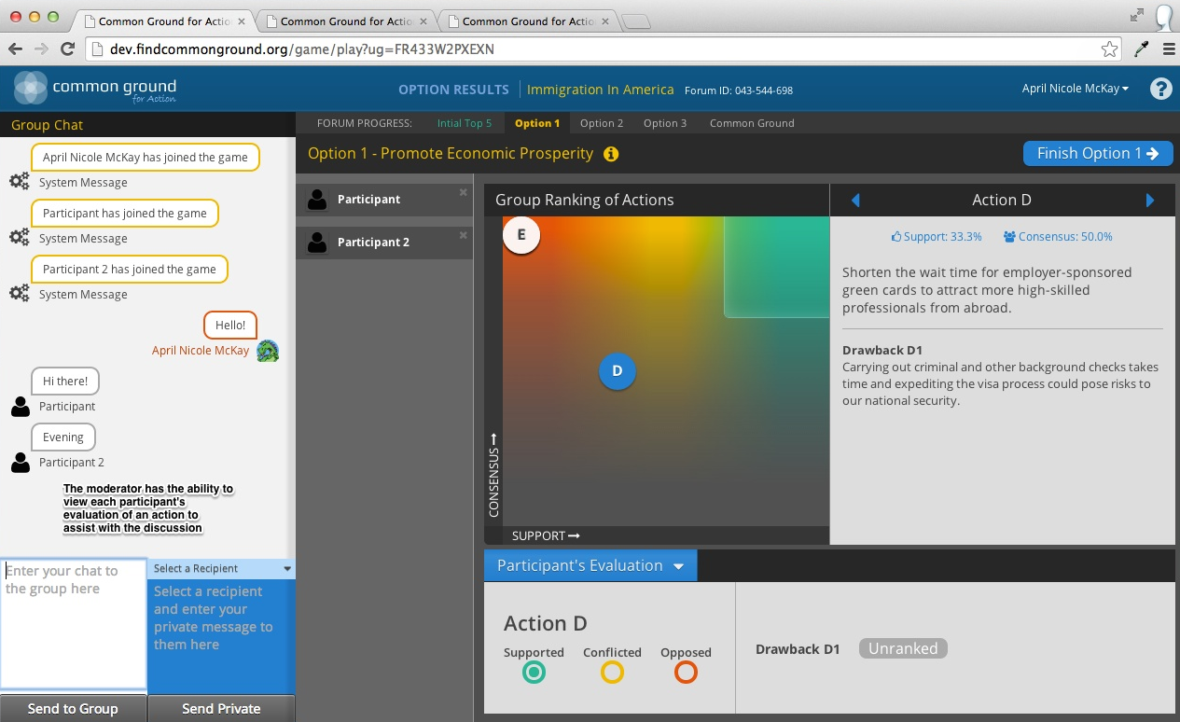 | Option 1 Initial Results + Deliberation | So, the graphic in the middle of the screen is an anonymized version of how the group evaluated the actions in this option.  Actions where people both supported the action and accepted the drawback are farthest right.  The agreement axis shows how mixed opinions were.  This is just a starting point for us to talk.  We’re going to talk for about 20 minutes on this issue. I’ll give us a warning when we only have 5 min left.  So, what can we say we think is positive about this option?  Looks like there’s strong support for …  Let’s start there. Anyone bothered by the tradeoff?  What about an action where we’re more mixed?  Don’t forget, if anything anyone says makes you change your mind at any point, you can always change your evaluation right below the graphic. Just click on the letter of the action you want to change, and then re-evaluate. The graphic will then update to show the shape the conversation’s going!  What about the tradeoff for this option as a whole?  Is there anything we NEED to cover before we move on?  All right, let me know if you’re ready to move on.
Repeat Option 1 Sequence for Options 2 & 3

- Evaluation (actions + drawbacks)
- Initial Results + Deliberation/Chat

WHAT MODERATORS SEE | WHAT PLAYERS SEE | MODERATOR TEXT FOR PASTING
COMMON GROUND REFLECTION  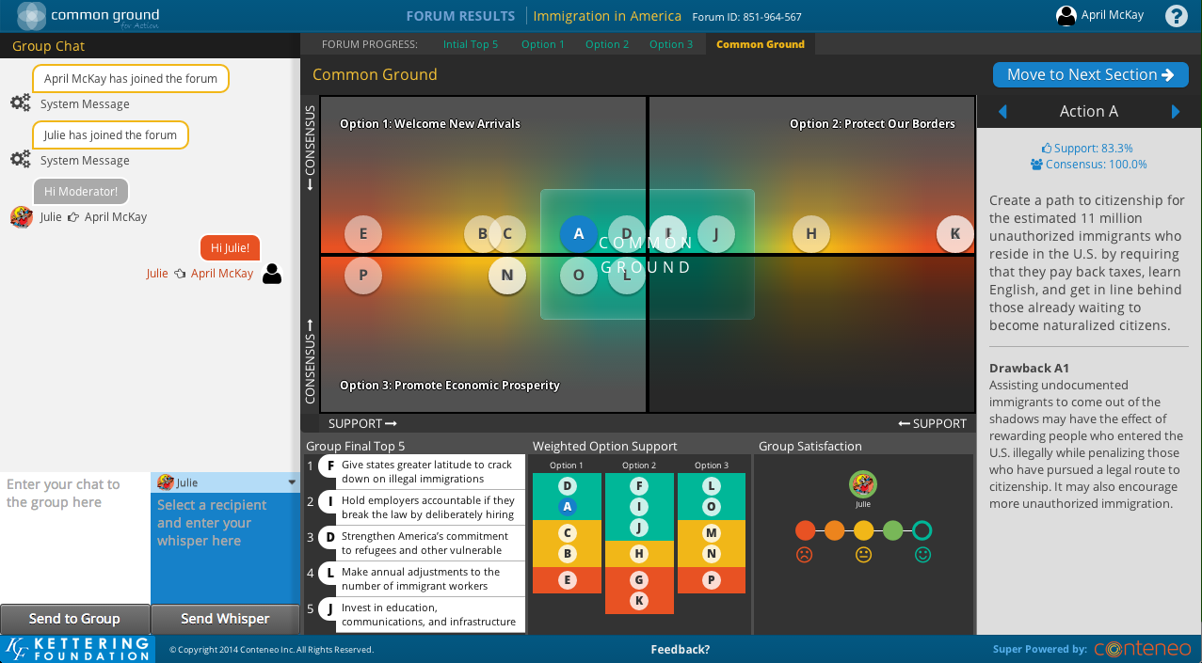 | COMMON GROUND REFLECTION  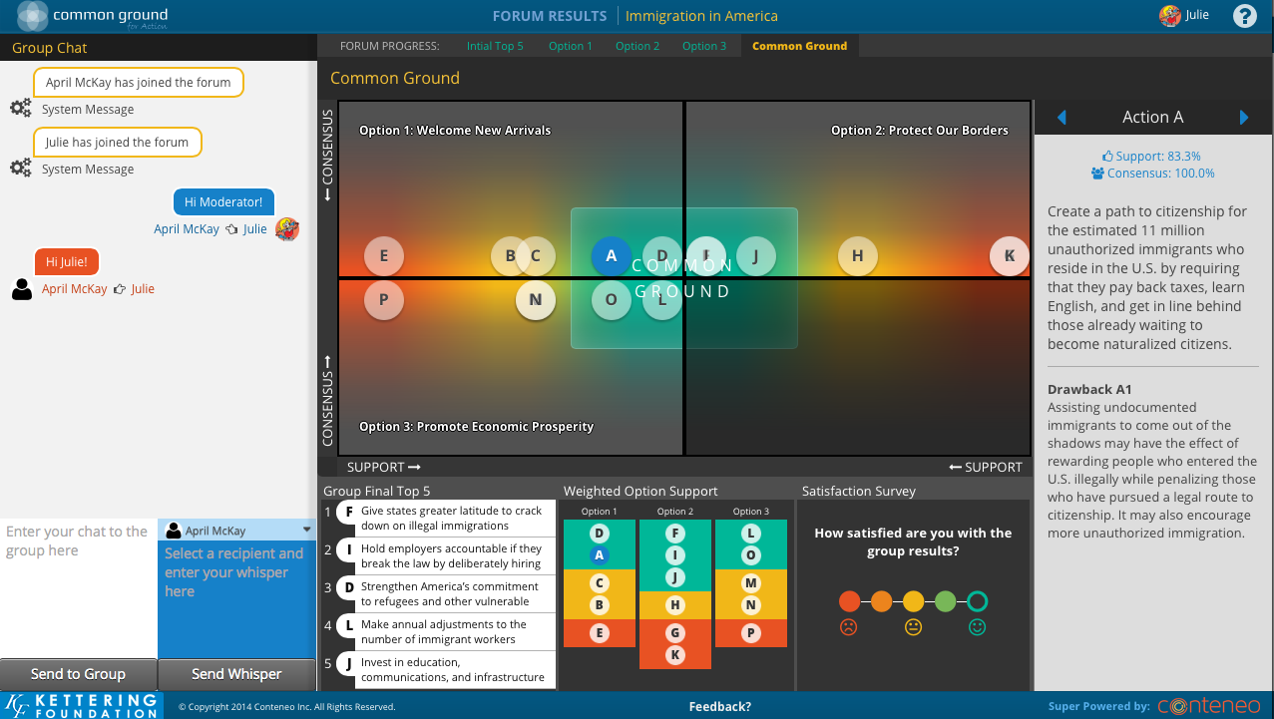 | THERE’S NO MORE INDIVIDUAL WORK AT THIS POINT, SO ALL TEXT CAN BE ENTERED INTO THE GROUP CHAT (WHITE BOX).  So, now we’re looking at our examinations of all three options together. The actions that are in the center are ones that had a high measure of agreement, plus strong support and acceptance of the drawback.  The other actions fall elsewhere in the map depending on how strong or mixed their support and consensus were.  So take a look, remember this is just a starting point for us to talk.  What do we think about the actions in Common Ground? Does this seem to represent our conversation?  What about some other actions that are fairly close to common ground— fertile ground, you might say.  What’s keeping us from being able to fully support that? The tradeoff? Why?  Take a look at the Support Per Option graphic in the bottom center, which shows us the blend of Options we came up with as a group. What do you think?  COULD YOU LIVE WITH THIS?  So, look at the little Satisfaction box next to the Support Per Action graphic. How satisfied would you be we actually implemented the blend of actions in Common Ground? Go ahead and click the dot that represents how you feel.  But let’s also talk about this: if we, as citizens and policymakers, took the actions in common ground, could you live with it? Why or why not?  Tell the truth— how would you feel if we actually took these actions?  LET PEOPLE KNOW WHAT’S NEXT  Alright, we have one last thing to look at: we’re going to be able to see the difference our deliberation has made.
WHAT MODERATORS SEE | WHAT PLAYERS SEE | MODERATOR TEXT FOR PASTING
THE DIFFERENCE DELIBERATION MAKES  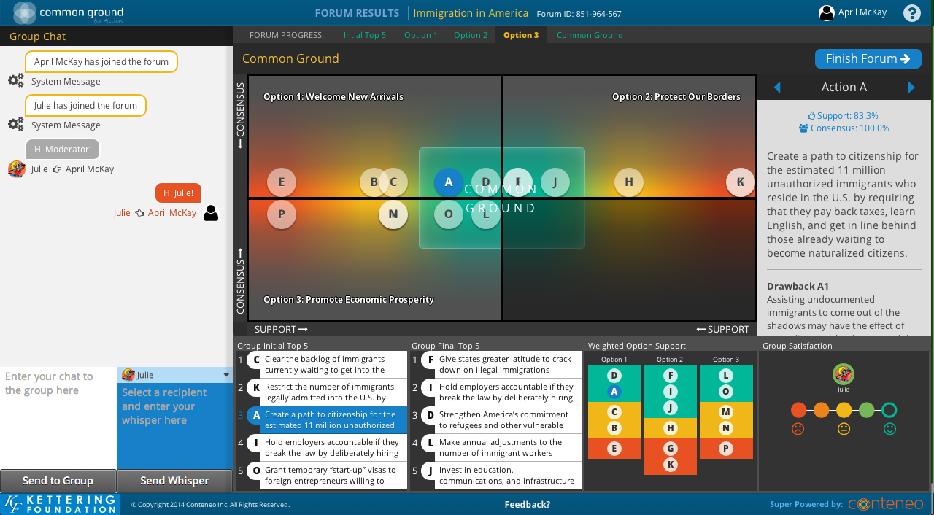 | THE DIFFERENCE DELIBERATION MAKES  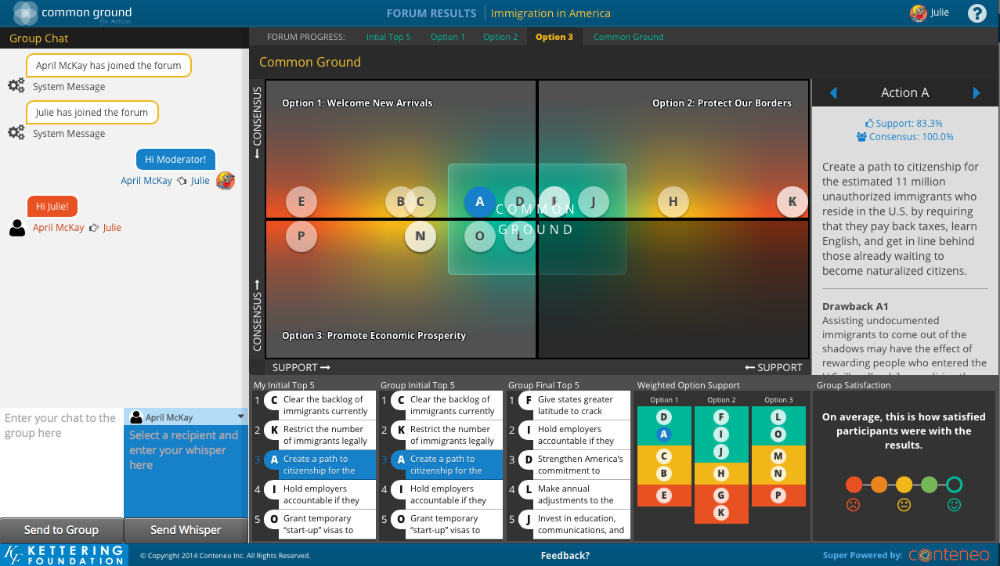 | In this screen, you can now compare the Common Ground the group found with your initial baseline, there at the bottom left.  In the center list below Common Ground, you can see what the group’s initial top 5 would have resulted in, if we’d just averaged everyone choices, like a poll or survey.  And then the last one is our group’s final top 5, which includes any Common Ground.  (CAN BE USEFUL TO NOTE SHIFTS BETWEEN GROUP INITIAL TOP 5 AND GROUP FINAL TOP 5)  What do you all think of how the judgment moved?  Has your thinking about the issue changed?  Has your thinking about other peoples’ views changed?  How has your perspective changed as a result of participating in this forum?  If we were to try to summarize our group's judgment coming out of this deliberation, what would you say?  Ok, the very last part of our forum is the post-forum questionnaire!  PASTE LINK TO POST-FORUM QUESTIONNAIRE FOR THE ISSUE GUIDE YOU USED.  ALL AVAILABLE ONLINE QUESTIONNAIRES LISTED HERE:  https://www.nifi.org/en/post-forum-questionnaires

